**Justice Party of Pennsylvania**

**Financial Report CY 2013**

**Prepared By:**   
Aaron Morris  
Treasurer

January 18, 2014

**Summary - CY 2013**

**Balances**

|  |  |  |
| --- | --- | --- |
| **Account** | **Beginning Balance (on January 1)** | **Ending Balance (on December 31)** |
| Checking (Orrstown Bank) | $50.00 | $187.06 |
| PayPal | $0.00 | $0.00 |
| **Total** | **$50.00** | **$187.06** |

**Cash Flow**

|  |  |
| --- | --- |
| **Beginning Balance** (on January 1) | **$50.00** |
| Receipts |  |
| *Monetary (e.g. .cash, check, credit card)* | *$160.00* |
| *In-Kind* | *$188.70* |
| Total Receipts | $348.70 |
| Disbursements |  |
| *Operating Expenses* | *$181.64* |
| *Advertising* | *$10.00* |
| *Refunds* | *$20.00* |
| Total Expenses | $211.64 |
| **Net Change** | **$137.06** |
| **Ending Balance** (on December 31) | **$187.06** |

**Financial Analysis for CY 2013**

**Income vs. Expenses by Payee – CY 2013**

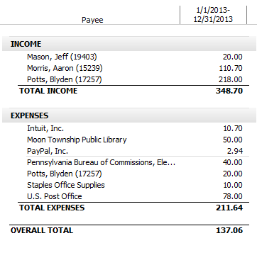

**Income vs. Expenses by Category – CY 2013**

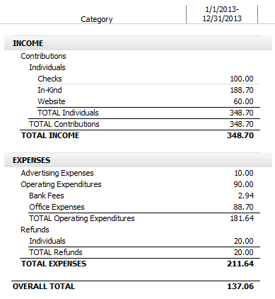

**Expenses by Category – CY 2013**

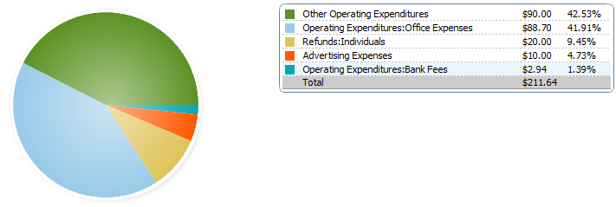

**Appendix A:   
Audit of Financial Activity**